Phase III: Software Design and Modeling

Submission Deadline

04/05/2026 – 23:59

1. Software Architecture

1.1 System Architecture
ALBus is a web-based system designed to manage Albania’s intercity bus network. It supports four main user roles: Admin, Operator, Driver, and Passenger. The system follows a three-tier architecture, consisting of the presentation layer, application layer, and data layer.
The presentation layer (frontend) is built using HTML, CSS, and JavaScript. Each user interacts with the system through role-specific interfaces such as Passenger UI, Operator Dashboard, Admin Panel, and Driver View.
The application layer (backend) is implemented using Spring Boot. It processes requests through controllers and services that apply business logic, such as booking tickets, managing routes, and handling payments.
The data layer consists of a MySQL database accessed through repository classes. It stores all system data, including users, trips, bookings, and route requests.

Example Flow – Passenger Booking a Trip
- Passenger enters origin, destination, and date
- Browser sends request to backend
- Backend checks available trips in database
- System returns list of trips
- Passenger selects trip and enters details
- BookingService assigns seats
- Booking is stored in database
- Confirmation is returned to the user

1.2 Component Diagram (UML)
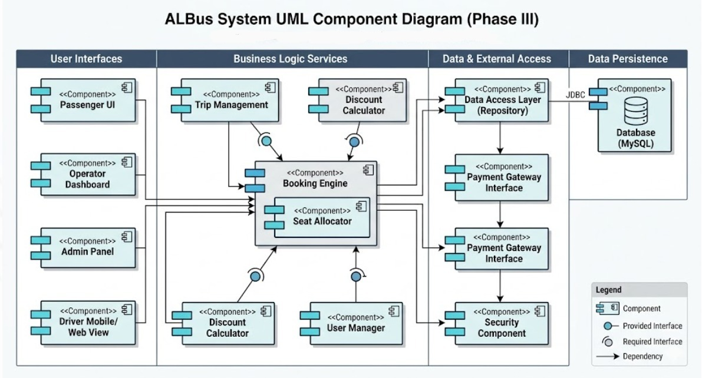

The component diagram represents the main structure of the ALBus system and how its components interact.
- User Interfaces (Frontend):
  - Passenger UI
  - Operator Dashboard
  - Admin Panel
  - Driver Mobile/Web View
These components allow users to interact with the system and send requests to the backend.
- Business Logic Services:
  - Trip Management
  - Booking Engine
  - Seat Allocator
  - User Manager
  - Discount Calculator
These components process the core logic of the system such as managing trips, assigning seats, and calculating prices.
- Data & External Access:
  - Data Access Layer (Repository)
  - Payment Gateway Interface
  - Security Component
These handle database communication, external payment systems, and authentication/security.
- Data Persistence:
  - MySQL Database
Stores all system data including users, trips, bookings, routes, and payments.

2. Detailed Design

2.1 Class Diagram
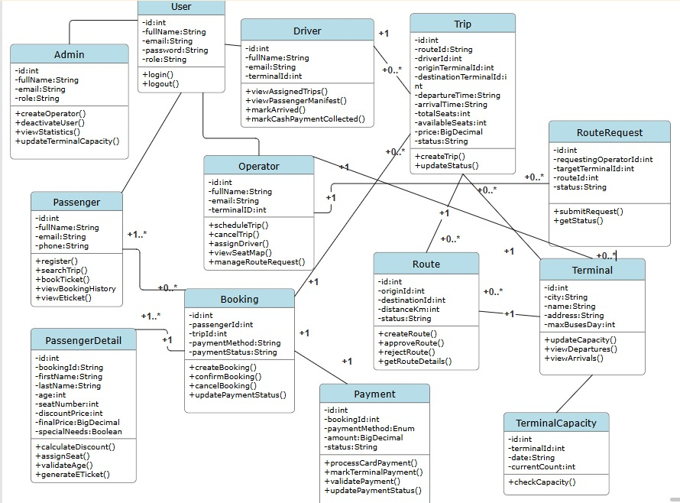
The class diagram represents the main structure of the ALBus system and the relationships between its entities.
- User is the base class that stores general information such as id, name, email, password, and role.
Admin, Operator, Driver, and Passenger extend this class and represent different system roles.
- Admin manages users, creates operator accounts, and updates terminal capacity.
- Operator manages trips, assigns drivers, and handles route requests.
- Driver views assigned trips, updates trip status, and manages passenger-related actions.
- Passenger searches trips, books tickets, and views e-tickets.
- Trip contains information such as route, driver, terminals, time, price, and status.
- Route defines the connection between origin and destination terminals.
- Terminal stores terminal data including city, name, and capacity.
- Booking links passengers to trips and stores booking details.
- PassengerDetail contains additional passenger information such as seat number, pricing, and discounts.
- Payment handles payment method, amount, and payment status.
- RouteRequest represents requests made by operators to create new routes.
- TerminalCapacity manages the number of buses allowed per terminal per day.

Relationships
- A passenger can have multiple bookings
- A booking is linked to one trip and one payment
- A trip is associated with one route and one driver
- A route connects two terminals
- An operator manages trips and route requests

2.2 Sequence Diagrams

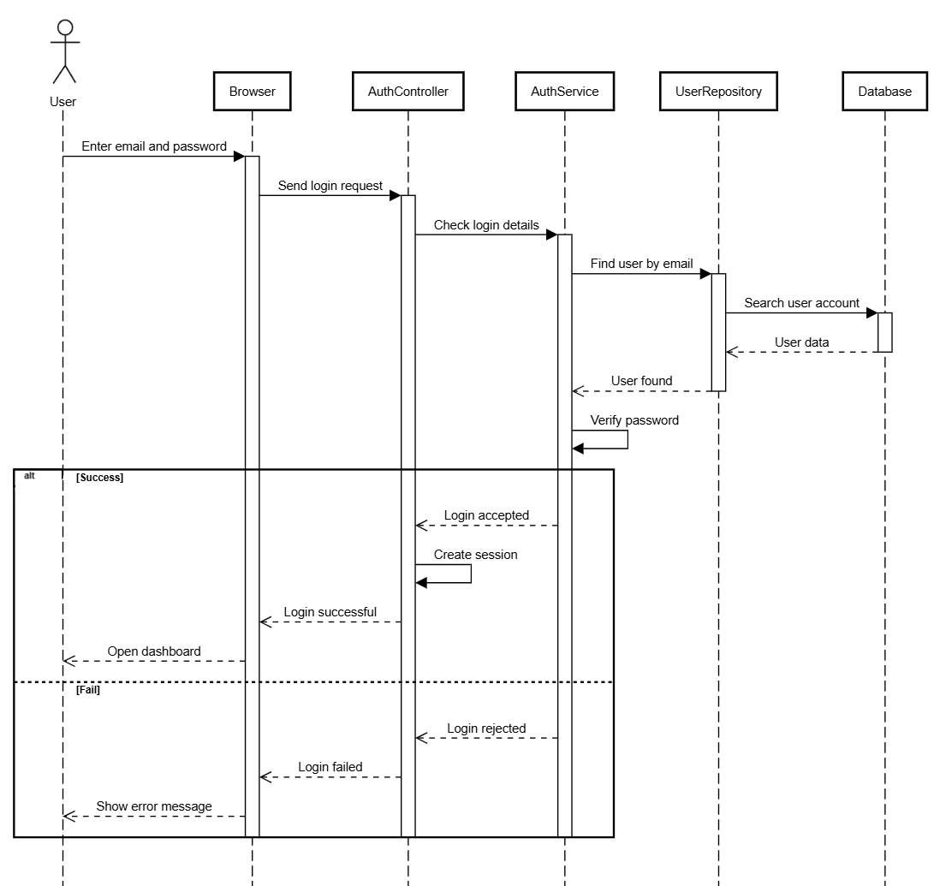
Sequence Diagram 1 – User Login

This diagram illustrates the process of user authentication in the system.
- The user enters email and password in the browser
- The browser sends a login request to the AuthController
- AuthController forwards the request to AuthService
- AuthService retrieves the user from UserRepository
- The system checks the password
- If credentials are valid:
  - A session is created
  - The user is redirected to the dashboard
- If credentials are invalid:
  - Login is rejected
  - An error message is displayed

Sequence Diagram 2 – Passenger Books a Trip
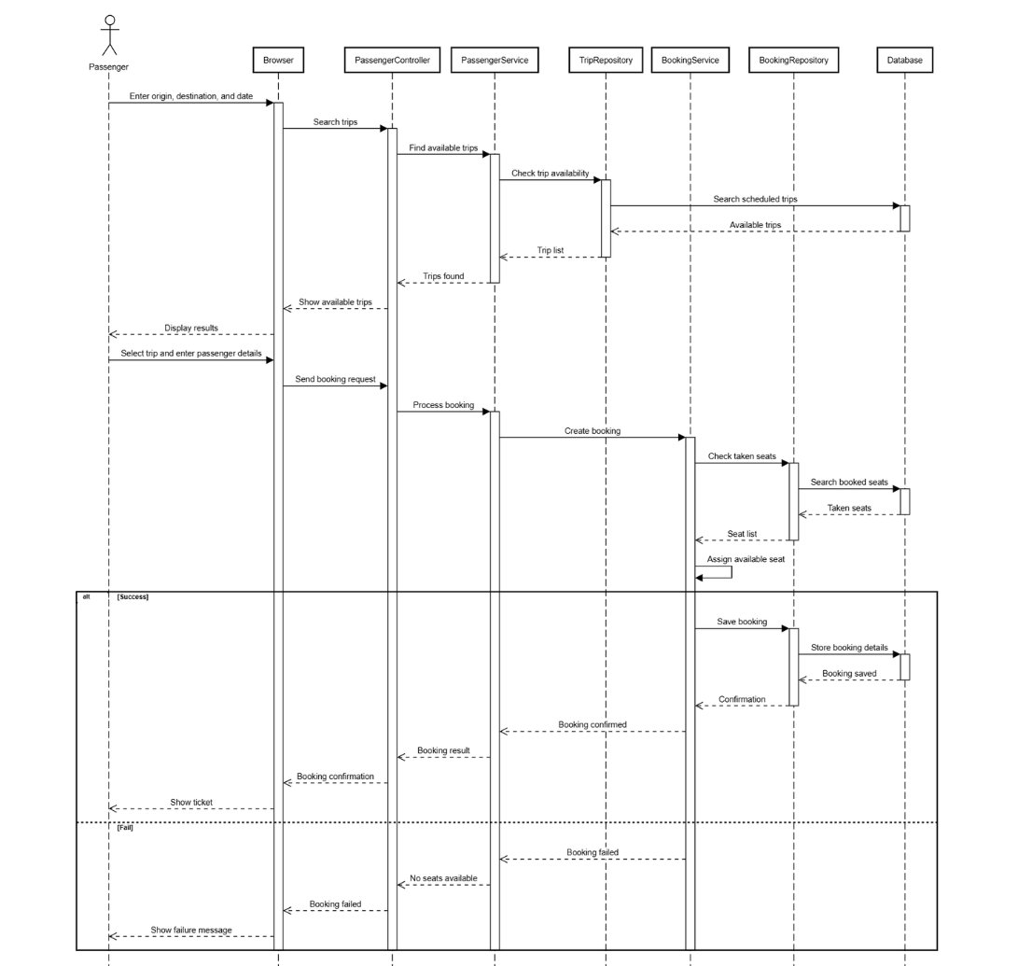
This diagram shows the booking process from searching trips to confirmation.
- Passenger enters trip details (origin, destination, date)
- Browser sends request to PassengerController
- PassengerService processes the request
- TripRepository checks available trips in the database
- Available trips are returned and displayed
- Passenger selects a trip and enters details
- BookingService processes the booking
- System checks already booked seats
- An available seat is assigned
- Booking is saved in the database
- Confirmation is sent to the user
Alternative Flow:
- If no seats are available → booking fails and error is shown

Sequence Diagram 3 – Operator Changes Trip Status
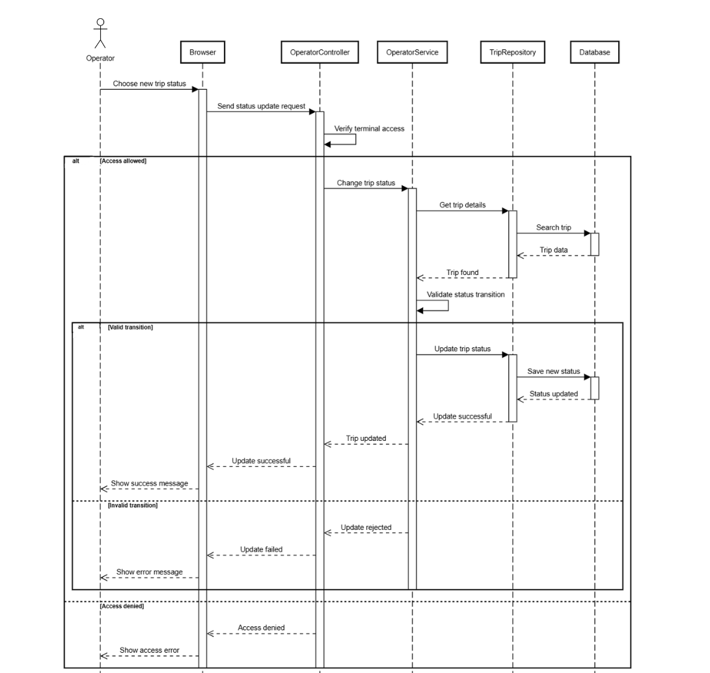

This diagram shows how an operator updates the trip status.
- Operator selects a new trip status
- Browser sends request to OperatorController
- System verifies terminal access
- OperatorService validates the status transition
- TripRepository retrieves trip data
- System checks if transition is valid
- If valid:
  - Trip status is updated in database
  - Success message is returned
- If invalid:
  - Update is rejected
  - Error message is shown
Alternative Cases:
- Invalid transition → rejected
- Access denied → operation blocked

3. Modeling

3.1 Use Case Diagram

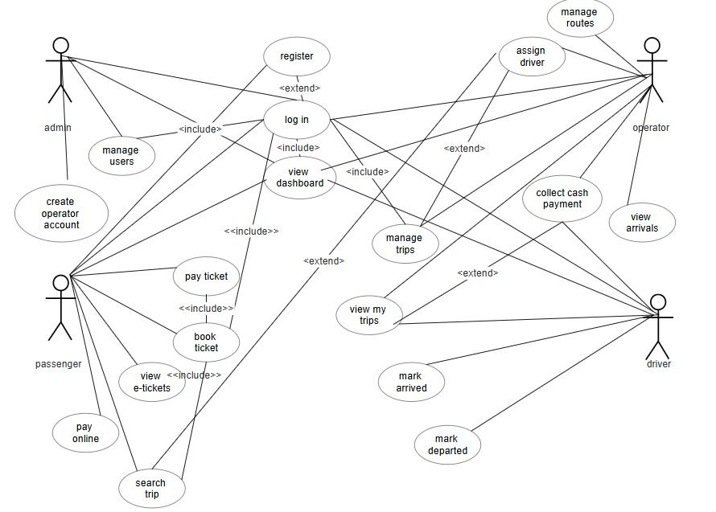
The use case diagram illustrates how different users interact with the system.

Admin
- Manage users
- Create operator accounts
- Access system functionalities

Operator
- Manage routes
- Assign drivers
- Manage trips
- View arrivals
- Monitor system operations

Driver
- View assigned trips
- Mark trips as departed
- Mark trips as arrived
- Collect cash payments

Passenger
- Register and log in
- Search trips
- Book tickets
- Pay online or at terminal
- View e-tickets

3.2 Activity Diagrams

Activity Diagram 1 – Passenger Booking Flow
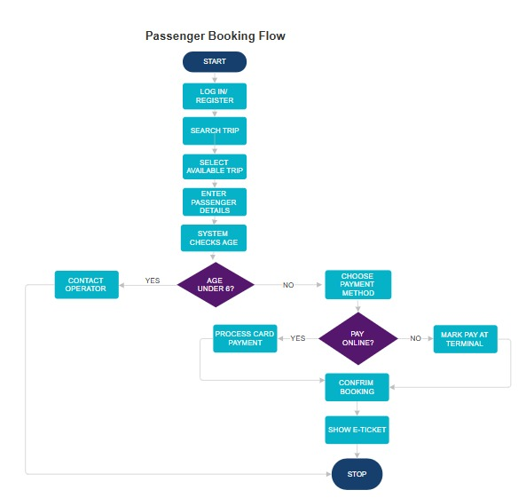
- Passenger logs in or registers
- Searches for a trip
- Selects an available trip
- Enters passenger details
- System checks conditions (e.g., age)
- Chooses payment method
  - Online → payment processed
  - Terminal → pay later
- Booking is confirmed
- E-ticket is generated
- Process ends

Activity Diagram 2 – Operator Trip Management Flow
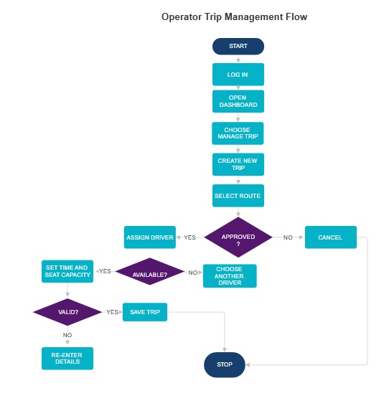
- Operator logs in
- Opens dashboard
- Selects manage trips
- Creates new trip
- Selects route
  - If not approved → cancel
- Assigns driver
  - If not available → choose another
- Sets time and seat capacity
- System validates details
  - If invalid → re-enter
- Trip is saved
- Process ends

3.3 State Diagrams

State Diagram 1 – Trip Status

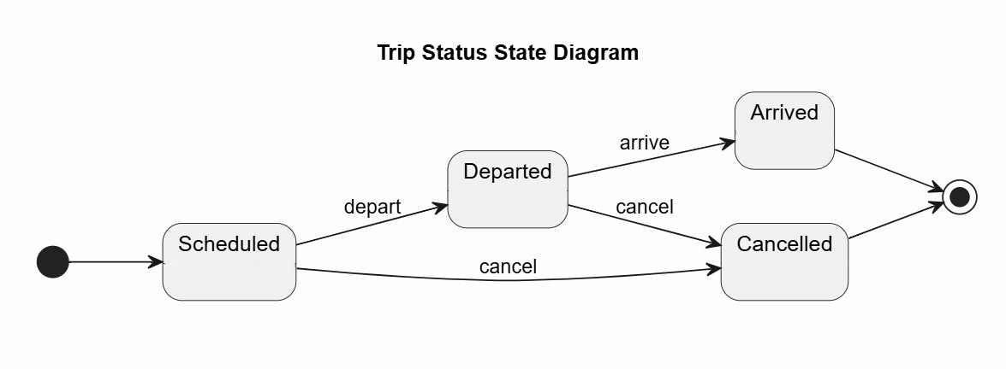
This diagram shows how a trip progresses through different states.
- Initial state: Scheduled
- Scheduled → Departed
- Departed → Arrived
- Trip can be cancelled from:
  - Scheduled
  - Departed
- Final states:
  - Arrived
  - Cancelled

State Diagram 2 – Booking Payment Status

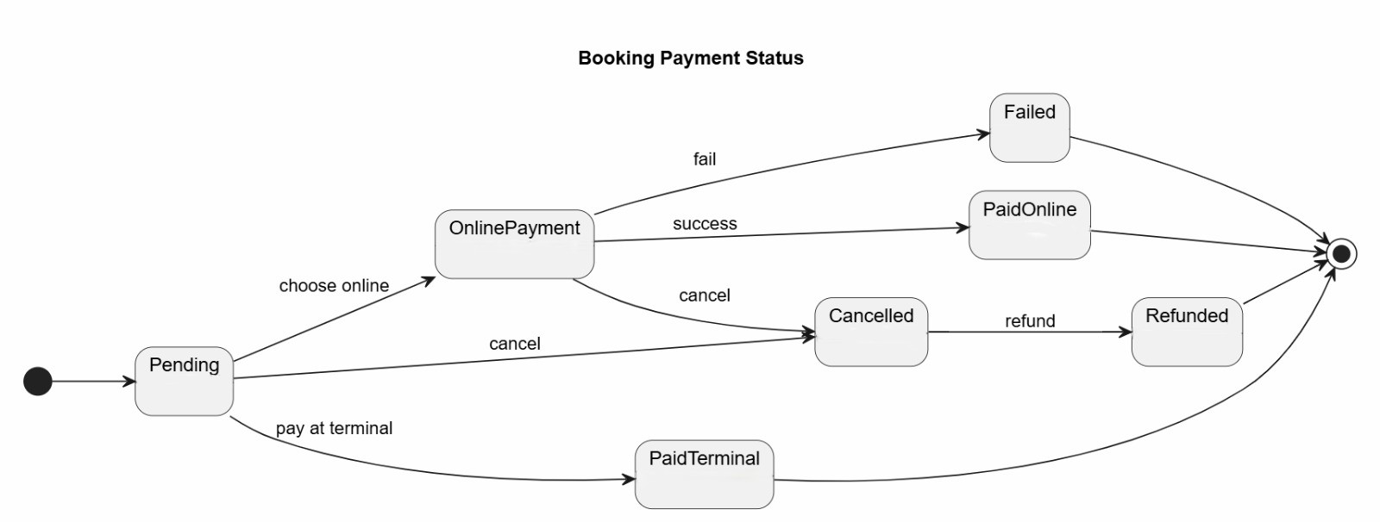
This diagram shows how payment status changes.
- Initial state: Pending
- User selects payment method
Online Payment:
- Success → PaidOnline
- Failure → Failed
Terminal Payment:
- Leads to PaidTerminal
Other Transitions:
- Booking can be cancelled → Cancelled
- Cancelled booking may be refunded → Refunded

State Diagram 3 – Route Request Status

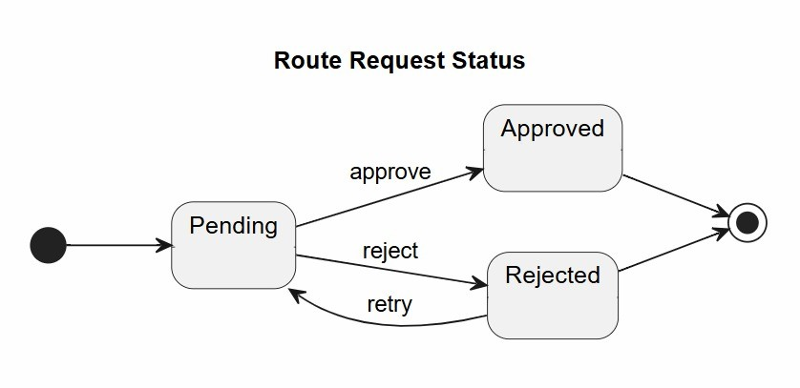
This diagram represents the lifecycle of a route request.
- Initial state: Pending
- Pending → Approved
- Pending → Rejected
Approved:
- Operator can create trips on the route
Rejected:
- Request is closed
- New request must be submitted to retry.

